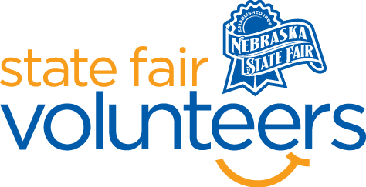
NSF Volunteer Information Sheet
Thank you for offering your time and efforts for the Nebraska State Fair! Your time is very valuable to us, and we appreciate everything that you have to offer to make the Nebraska State Fair a success.

Volunteer Position: AgTivity Acres & Jumping Pillow Volunteer
Date/s: Friday, August 22nd – Monday, September 1st
Shift/Time Needed: 10:00 am – 9:00 pm
Number of Volunteer/s Needed: 2 per shift per day

• Check-In:
- Your yellow name badge will be your gate admission into the fair. It is to only be used on days that you are volunteering.
- All volunteers are required to check-in with the volunteer coordinator at Volunteer Headquarters (VHQ) in the Pinnacle Expo Building prior to their shift.
- VHQ assistants will check you in and answer any questions you have before your shift begins.
- Please check in 15 minutes prior to the start of your shift.

• Location:
- Family Fun Zone

• Responsibilities:
AgTivity Acres:
- Assist with prepping the space for the day.
- Monitor the various activity spaces:
- Corn Sandbox: A few large corn sandboxes will provide an area for young kids to play in with toy tractors, shovels, etc.
- Grocery Store: an interactive grocery store will teach kids about what types of food are raised on farms and then sold in store.
- Other miscellaneous agricultural features throughout the space
- Keep the AgTivity Acres area organized and be available to explain to parents the different activities the kids can enjoy in this free zone.
- Assist with organizing the AgTivity Acres at the end of the day. Place all loose items from the area in the grocery store on last shift for next day volunteers to set up.
Jumping Pillow:
- Monitor the jumping pillow ensuring that the number of people does not exceed the maximum limit.
- Follow the provided guide to ensure that the jumping pillow remains safe for Fair Guests (to include inflation/deflation guidelines, who to contact if there are issues, checking the pillow for debris, etc.)

• Requirements:
- Indoors or Outdoors: Outdoors; combination of sitting and standing
- Lifting Requirements: Lifting of less than 5 lbs.

• Check-Out:
- Volunteers do not need to check out at VHQ as the new system will automatically check you out.

